|  |
| --- |
|  |
| TFRS9 Model Development Document |
| K-Leasing |
|  |
|  |
|  |

Document History

This section documented the revision history and version control of this document. It shall record every major and minor revision of the model development regarding the development of Probability of Default (PD), Exposure at Default (EAD), and Loss Given Default (LGD) models modules which are used for the purpose of calculation of ECL of the TFRS9 accounting book.

Revision History

|  |  |  |  |  |  |  |
| --- | --- | --- | --- | --- | --- | --- |
| **Version** | **Phase** | **Revision Date** | **Summary of Changes** | **Page** | **File name** | **Changed by** |
| 1.0 |  | 14-Jun-19 | Initial version |  | KBank_TFRS9_Model_Development_Document_KL_V1.0_190614 | Nittha.p |

Reviewer

|  |  |  |  |
| --- | --- | --- | --- |
| **Name** | **Version** | **Signature** | **Review Date** |
| Lalita Limtongsittikun | 1.0 |  |  |
| Thepdanai Danswasvong | 1.0 |  |  |
| Panrit Tosukhowong | 1.0 |  |  |
| Nareerut Poolpun | 1.0 |  |  |

Approvals

|  |  |  |  |
| --- | --- | --- | --- |
| **Name** | **Version** | **Signature** | **Approve Date** |
| Duangporn Kit-o-pas | 1.0 |  |  |
| Sanphet Sukhapesna | 1.0 |  |  |

# Introduction

Probability of default (PD), Exposure at default (EAD), and Loss Given Default (LGD) are three components which are used to calculate credit risk capital and provision. In this document, we are focusing on risk parameter model development used in KLeasing portfolio which is car leasing business. KLeasing portfolio consists of about 180,000 customers and total outstanding is about 68,900 million.

In the current regulatory setting, the provisioning of expected credit loss is calculated from inherent risk parameters; the probability of default (PD), exposure at default (EAD) and loss given default (LGD). Each parameter is estimated by average through the economic cycle from 2007 to 2009 which can be considered as a downturn situation. However, these risk parameters does not reflect future risk exposure. Hence, the TFRS9 which is a new accounting standard is introduced. The impairment under TFRS9 setting also covers forward-looking components which should help improve financial stability and improve bank credit risk.

This document outlines the development process of all model related to the TFRS9 calculation. For each risk component, this document shall clearly state the scope (model usage), methodology considered, model development approach, final model and the initial validation results.

## Portfolio Segmentation

KLeasing portfolio consists of 3 main product including New Car, Used Car and KCar. Proportion of each product in KLeasing portfolio by outstanding is shown below.

|  |  |
| --- | --- |
| **Product** | **Outstanding** (MB) |
| New Car | 57,375 |
| Used Car | 88 |
| KCar | 11,453 |
| **Grand Total** | **68,916** |

# TFRS9 Expected Credit Loss

On July 24, 2014, the International Accounting Standards Board (IASB) issued the final version of the ‘International Financial Reporting Standard (IFRS) 9 – Financial Instruments’. As a primary component of the new accounting standard, the IASB introduced a forward looking impairment model. The IASB thereby reacted to delayed recognition of credit losses identified as a weakness of existing accounting standards during the course of the global financial crisis (of 2007/08). In particular, the biggest critique of incurred loss approach under IAS 39 was the recognition of credit losses only upon evidence of a trigger event. In this regard, IASB’s approach of forward looking credit loss estimation was evident from the below extract.

*“The new standard requires an entity to recognise expected credit losses at all times and to update the amount of expected credit losses recognised at each reporting date to reflect changes in the credit risk of financial instruments. This model is forward-looking and it eliminates the threshold for the recognition of expected credit losses, so that it is no longer necessary for a trigger event to have occurred before credit losses are recognised. Consequently, more timely information is required to be provided about expected credit losses.” [“Project summary – IFRS 9 Financial Instruments”, IFRS Foundation, 07/2014, p.14][1]*

Following the publication of IFRS 9 Financial Instruments in July 2014, the Basel Committee on Banking Supervision issued their ‘Guidance on Credit Risk and Accounting for Expected Credit Losses’ (GCRAECL) in December 2015. This covers in particular the impairment (Expected Credit Losses) element and how it should be embedded in and supported by internal processes.

Thai Accounting Standards are substantially converged with IFRS Standards, though the financial instruments Standards that are part of IFRS Standards have not yet been adopted. Thai Accounting Standards include several national financial instruments standards that differ from IFRS Standards. Henceforth TFRS9 can be considered as an adaptation from IFRS9 and replaces the existing TAS101.

***Principle 5 states****–A bank should have policies and procedures in place to appropriately validate models used to assess and measure expected credit losses. This presentation will provide an overview of the scope of work and the proposed validation approach for KBank, based on further discussions we will provide a more detailed view of the approach based on the complexity and materiality of the underlying models.*

Changes due to ‘*IFRS 9 – Financial Instruments*’ can be grouped into three categories.

* ***Classification and measurement***: Classification determines how financial assets and liabilities are accounted for in financial statements and, in particular, how they are measured on an ongoing basis:
  + Assets: one classification approach
  + Liabilities: addressing the volatility in profit or loss caused by changes in the credit risk of financial liabilities that are measured at fair value
* ***Impairments***: Forward-looking impairment model based on expected losses:
  + The new model requires entities to recognise expected credit losses at all times (12-month or lifetime expected loss) which includes measurement of changes in expected credit losses
  + It is no longer necessary for a trigger event to have occurred before credit losses are recognised
  + The new model is also accompanied by improved disclosures about expected credit losses and credit risk
* ***Hedge accounting***: Clear alignment with risk management:
  + The rules allow components of non-financial items to be hedged (previously not allowed by IAS 39)
  + IFRS 9 eliminates the distinction between financial and non-financial items and looks at whether a risk component can be identified and measured and therefore reflected in management activities

The primary change from IAS 39 to IFRS 9 is the evolution from an incurred loss view to a forward looking expected loss view which needs to be accounted for in the impairment models.

This new accounting standard will be effective from 2020. The IFRS 9 standard provides a new set of regulations that the new loss provisioning process will need to satisfy.



Figure 1, From IAS39 to IFRS 9

In particular, the new impairment rules require that the lifetime credit risk of an account be assessed at each model run to determine if there has been a significant increase in credit risk since origination. For accounts where the credit risk has significantly increased (including defaults) the lifetime expected credit losses must be used. If the credit risk has not significantly increased, then only credit losses resulting from expected defaults in the next 12 months must be used. The approach is outlined in terms of a stage classification accounting for significant increase in credit risk as a pivotal element of IFRS 9.

**Table 1: Stages under IFRS 9**

|  |  |  |  |
| --- | --- | --- | --- |
|  | **Stage 1** | **Stage 2** | **Stage 3** |
| **Stage description** | Includes accounts for whom no significant increase in credit risk since initial recognition has been observed | Includes accounts whose credit risk has significantly increased since initial recognition but no objective evidence of impairment has been observed, with a rebuttal presumption that this occurs when the account reaches 30 days past due | Includes accounts where the objective evidence of impairment has been observed |
| 12-month expected credit losses, i.e. credit losses due to default events within subsequent 12 months, are recognised in balance sheet | Lifetime expected credit losses (LTECL) i.e. credit losses due to default events spanning the (expected) lifetime of the facility, are recognised in balance sheet | Lifetime expected credit losses (LTECL) are recognised in balance sheet |
| **Expected loss** | IFRS 9 guidelines require to assess the 1 year expected credit losses without prescribing the tangible estimation procedure    , , , represent marginal PD, EAD and LGD at time *t* | IFRS 9 guidelines require the lifetime expected credit losses without prescribing the tangible estimation procedure   Where, , , , represent marginal PD, EAD and LGD at time *t* and *T* represents the remaining lifetime of the account | Expected loss of a defaulted client given the loss rate, i.e. the shortfall in net present value of expected cash flows versus the carrying amount of the loan |

Table 1, Stages under IFRS 9

The exemplary expected loss (EL) assessment in Table 1 listed above is based on an estimate of 1 year parameters probability of default (PD), loss given default (LGD) and exposure at default (EAD) for stage 1 and multi-year PD, LGD and EAD assessments for stage 2 including a discount factor to the reporting date.

# Definition

| **Term** | **Acronym** | **Description** |
| --- | --- | --- |
| Days Past Due | DPD | The number of days that an account is currently in arrears |
| Delinquent |  | An asset is described as delinquent if it is associated with any amount of arrears |
| Expected Loss/Expected Credit Loss | EL/ECL | Interchangeable terms. EL = PD*EAD*LGD |
| Exposure at Default | EAD | Estimation of the extent of the exposure at the point of default |
| Forward in Time | FiT | This represents an TFRS 9 version of the Point in Time (PiT) PD used in Basel capital models. Under TFRS 9 the best expectation of future default risk is modelled as a series of marginal future default probabilities rather than a single cumulative value as represent by a PiT PD, hence it is described as being “Forward” in Time. |
| Forward-Looking |  | The required element by TFRS 9 to consider future expected events e.g. economic forecasts when calculating the expected losses on assets |
| International Accounting Standard 39 / FRS 139 – Financial Instruments – Recognition and Measurement | IAS 39 / FRS 139 | Terms generally used interchangeably to describe current accounting standards |
| Lifetime Expected Credit Loss | LTECL / LEL | The Expected Credit Loss over the behavioural lifetime of an asset |
| Lifetime Probability of Default | Lifetime PD | The Probability of Default of an account, calculated at the behavioural lifetime of an asset |
| Default customer |  | Default customer is customer who failed to make on-time repayment (>= minimum payment rate) of their loans for more than ninety consecutive days or three months. |
| Conditional Prepayment Rate | CPR | Conditional Prepayment Rate (CPR) is the annualized percentage of the mortgage expected to prepay in each period. For example, if CPR is 5%, it means that 5% of mortgage is expected to prepay within the period. The focused population is the group of opening accounts at the end of time frame. |
| Recovery Rate |  | Recovery Rate is cash flow that can be collected from default customers, expresses as a percentage of exposure at defult. |

Table , Term definition and description

# Probability of Default

Probability of default (PD) is the risk that the borrower will be unable or unwilling to repay its debt in full or on time. The risk of default is derived by analyzing the obligor’s capacity to repay the debt in accordance with contractual terms. PD is generally associated with financial characteristics such as inadequate cash flow to service debt, declining revenues or operating margins, high leverage or declining liquidity.

With the new IFRS9 loan loss provision, loans are classified in three stages: stage 1 – initial recognition (yet to be impaired), stage 2 – significant increase in credit risk, and stage 3 – objective indicators of impairment. For loans in stage 1, banks need to estimate 1-year expected credit losses. On the other hand for loans in stage 2 and 3, banks need to provide provision and thus estimate expected credit losses for the whole lifetime of the loans. Both the 1-year and lifetime expected credit losses estimation shall reflect the banks’ forward looking macro-economic view.

KBank’s PD estimation for IFRS9 is modelled according to the following principles: (i) the PD estimation for IFRS9 should be point-in-time (PIT) and reflect current market conditions, (ii) the PD estimates should use structural and behavior information, and (iii) estimation of PD should include the forward looking aspect of the macroeconomic outlook specific to particular sector. For loans in stage 1 and 2, the modelled probability of default will be over 12 months and lifetime respectively. For stage 3, the probability default will be at 100%.

KBank leverages existing behavioral scorecard to construct a new credit rating system (supermaster rating) and then use it to create the probability of default term-structure of each obligor up to its maturity based on a continuous time homogeneous or non-homogeneous Markov transition matrix and then incorporate systematic risk into PD term-structure model via Vasicek model for calculating joint loss distribution of bank exposures (Vasicek, 2002).

This section outlines step by step Probability of Default (PD) model development methodology for the champion model and states its compliance with the current IFRS9 regulatory requirement. It also documented all the technical difficulties that the model developer experienced undergoing these model development steps.

## Scope

This probability of default model should be used to create the PD term structure for all valid stage-1 and stage-2 K-Leasing instruments. For stage-3 instruments, they are automatically assigned to be at 100%.

## Methodology Review

KBank leverages existing behavioral scorecard to construct a new credit rating system (supermaster rating) and then use it to create the probability of default term-structure of each obligor up to its maturity based on a continuous time homogeneous or non-homogeneous Markov transition matrix and then incorporate systematic risk into PD term-structure model via Vasicek model for calculating joint loss distribution of bank exposures (Vasicek, 2002).

The existing behavioral scorecard is regarded by the bank as a feeder model to the TFRS9 probability of default model. Hence, this document does not extend to the model development and validation of the current behavioral scorecard.

For KBank retail portfolio, we explore a way to construct PD term structure by applying Markov state transition model. The Markov property represents the assumption that the evolution of credit migration is independent of the past credit migration history. In other words, the probability of migration from rating class to rating class does not depend on any information from the past, only the current rating matters. To find out the best credit migration for our corporate lending, we consider several alternative approaches: (i) discrete time Markov transition, (ii) homogeneous continuous time Markov transition, and (iii) nonhomogeneous continuous time Markov transition.

### TTC PD: Discrete Time Markov Transition (DTMT)

We first consider a discrete time Markov chain. Let be a discrete-time transition matrix

where denotes the probability of change in rating at the beginning of a year to rating class at year’s end. In total, we have ratings (states). The final rating represents a default state.

A useful property of the time homogeneous Markov transition matrix is the fact that the *n*-year transition matrix is simply given by the *n*th power of the one-year transition matrix , denoted by i.e.

[Matrix multiplication times]

The cumulative nth year default probabilities for a starting rating class is the last column of ,

The model assumes that probability of state (rating) transition only depends on the current information (current rating) i.e. rating transition exhibit Markov property. In reality, the rating migration needs not to be stationary or time-homogeneous and the maturity of loans need not be a yearly increment. We explore further to identify a more suitable approach to model the probability of default term structure.

### TTC PD: Homogeneous Continuous Time Markov Transition

A continuous time, time-homogeneous Markov chain is predicated in terms of a symmetric generator matrix (for possible transitory states)

where for all , and for

The transition matrix for time interval is given by

where denotes the matrix exponential

However, there is evidence that the assumption of time-homogeneity is very likely not precisely true for real credit ratings migration. We therefore consider nonhomogeneous time Markov chain and would like to find that best represent the dynamics of PD migration. That is, we no longer assume that the transition rates  are constant over time. This will be done using parametric approach.

### TTC PD: Non Homogeneous Continuous Time Markov Transition

We replace the homogeneous generator for the time interval by the time-dependent-generator:

where X denote matrix multiplication and is the diagonal matrix in with elements of as follow

The function is defined as follow

Where, , are non-negative constant and time .

Finally, we decide to apply nonhomogeneous continuous time Markov transition to forecast the dynamics of PD migration for our lending portfolio, because it better reflects seasoning effects and improves the fit, especially on the lowest and highest ratings.

### PIT PD: Vasicek (2002) and Credit Adjustment Factor

Previously, we derive TTC PD term structure or accumulative PD for, say, n years. The forward PD is then calculated and defined as the probability of the loan has defaulted by the end of year n, minus the probability of the loan had already defaulted before the beginning of year n. That is, the forward PD is the difference between the n-year and the n-1 year accumulative PD.

Our approach to convert forward PD to PIT PD is through the application of the Vasicek (2002) equation using a Cycle Adjustment Factor (CAF). The PIT PD for year t is given by:

Where is the cumulative standard normal distribution function

is the cumulative inverse standard normal distribution function

is the asset-segment correlation

or Cycle Adjustment Factor is the normalized risk factor that represents the point in the economic cycle

is the forward PD for an individual obligor/rating

is the PIT PD for an individual obligor/rating

We next find the fitted CAF model by seeking relationship between credit index (Z) and macroeconomic factors. That is, we regress the normalized historical credit index against the historical macroeconomic factors. The macroeconomic factors are assumed to be exogenous to the model and are listed in Table 3 together with their expected signs.

|  |  |  |
| --- | --- | --- |
| No. | Macroeconomic Factors | Expected Sign |
| 1 | Private Consumption | - |
| 2 | Investment | - |
| 3 | House Price Index | - |
| 4 | Unemployment Rate | + |
| 5 | Diesel Price | - |
| 6 | Household Debt | + |

Table 3, List of macroeconomic factors and their expected signs

*Grouping criteria and asset correlation*

Credit Adjustment Factors (CAF) in different homogeneous asset classes are naturally different based upon their economic drivers. Since commercial portfolio is based on systematic factors in industry, we develop CAF by Occupation: Salary Earner and Entrepreneur.

To develop the econometric model, a direct regression of the observed actual default against the macroeconomic factors is performed. The estimated regression equation is

Where measure the “credit cycle” at time t and is the OLS estimates which minimize the sum of squared error. In addition, the macroeconomic factors that are selected into the final fitted CAF model should fulfill the following conditions:

1) Its coefficients should be significant (p-value < 0.05)

2) Its coefficients should be consistent with economic theory as well as improve the overall model’s performance (e.g. adjusted R2).

Finally, given the forecasted macroeconomic factors, we can calculate CAF for the forecasted period. In conjunction with forward PD estimates, we then calculate forward-looking PIT PD using the above-mentioned Vasicek equation where is the best fit between actual and predicted model.

## Model Development Approach

For PD term structure model, KBank believe that the Markov state transition model family is the appropriate methodology for the construction of PD term structure. The inputs of the model and the development exercise align with the bank’s current data structure. The output of model also aligns with current business model and TFRS9 risk requirements in term of generating the default term structure.

KBank explore the possibility of instigating the non-homogeneous continuous time Markov state transition model (NHCTMT) as a champion model for K-Leasing PD term structure. But depending on the results of the curve adjustment optimization, KBank may opt to revert to the homogeneous model instead. Additionally, KBank also attempt to use the survival analysis methodology to create the default term structure as a challenger model.

Figure 2, Steps of PD term structure model development

This section briefly outlines the steps that have been taken in the development of the champion model (NHCTMT) for the TFRS9 probability of default term structure.

The model development process starts with data gathering and sample preparation. We used a long history of default performance, B-score and TDR-score in the derivation of our supermaster rating and 1-year through-the-cycle probability of default. This will be elucidate in detail in the next section of this document.

After the supermaster rating and scale has been well developed, we re-apply the rating criteria to our historical observations and observed the 1-year rating migrations over different observation periods. We constructed our through-the-cycle 1-year state transition probability based on the average migration rates across years of observation. The next step involves human intervention in order to smooth out and ensure that the TTC rating migration matrix comply with the necessary conditions of the NHCTMT model (will be discussed later).

After the TTC migration matrix has been finalized, we transform it to the generator matrix. We use this generator matrix together with an optimization algorithm to find appropriate curve adjustment parameters and . The objective of the optimization algorithm is to find the curve adjustment parameters such that the PD curves are the closest to and still cover the historical default rates across all ratings.

## Data Management

### Overview of Input Data Set

The first step of our model development is the derivation of supermaster scale. We gathered K-Leasing portfolio data and B-score of each instrument from 2012-01 to 2016-05.

|  |  |  |  |
| --- | --- | --- | --- |
| No. | Field_Name | Existing/New | Description |
| 1. | POS_DT | Existing | Data as of observation point |
| 2. | LPM_NO | Existing | Customer ID |
| 3. | ASSET_CLASS | Existing | Asset class of customer is to identify Good/Bad customer. If the asset class contains “NPL” then it is defined as bad if not then it is defined as good. |
| 4. | B_score | Existing | Customer Level B-Score (minimum from account level) |
| 5. | Supermaster_rating | New | Supermaster rating derived from 2.1 |

Table 4, Input data

From the data we observe portfolio actual default and construct a new super master rating. Subsequent to the completion of the supermaster rating, we observe a rating migration of the same observation and performance period. This process is outlined in the figure below.



Figure 3, Observation and outcome of default event and rating transition

We also utilize occupation data to explore the possibility of segmentation of the migration matrices.

### Development Sample Design

The observation point is every quarter starting from January 2012 to May 2016. The performance period for observation of actual default or rating migration is 12 month from the observation point i.e. January 2012 to May 2017.

### Data Cleansing and Exception Handling

In the construction of our development sample, at every observation point we exclude records using the following rules

|  |  |  |  |
| --- | --- | --- | --- |
| # | Issue | Detail | Handling |
| 1 | NPL record | The record/customer is NPL at the observation | Remove from sample |
| 2 | Open less than 3 months | The record/customer is new and there is no behavioral score | Remove from sample |
| 3 | No performance | The record/customer with no performance i.e. closure, write-off etc. | Remove from sample |

Table 5, Data cleansing and exception handling rules

### Final Development Sample

This section show step by step derivation of our final model development sample. Starting from the entire data set, working the way through record exclusion and thus the final development sample and associated bad rate.

Tables below show the number of customers in each of the observation point before and after exclusion.

|  |  |  |  |  |  |  |  |  |
| --- | --- | --- | --- | --- | --- | --- | --- | --- |
| Asset Class/Month | Jan-12 | April-12 | July-12 | Oct-12 | Jan-13 | April-13 | July-13 | Oct-13 |
| Final Model Development Sample | | | | | | | | |
| Total | 133,179 | 136,315 | 145,992 | 147,975 | 157,935 | 163,493 | 168,850 | 175,585 |

|  |  |  |  |  |  |  |  |  |
| --- | --- | --- | --- | --- | --- | --- | --- | --- |
| Asset Class/Month | Jan-14 | April-14 | July-14 | Oct-14 | Jan-15 | April-15 | July-15 | Oct-15 |
| Final Model Development Sample | | | | | | | | |
| Total | 178,988 | 182,211 | 183,701 | 185,518 | 186,817 | 185,981 | 184,927 | 182,822 |

|  |  |  |  |  |  |  |  |  |
| --- | --- | --- | --- | --- | --- | --- | --- | --- |
| Asset Class/Month | Jan-16 | April-16 |  |  |  |  |  |  |
| Final Model Development Sample | | | | | | | | |
| Total | 184,323 | 183,327 |  |  |  |  |  |  |

Table 6, Observations and development samples

The performance of the development sample (i.e. number of bad customers within the defined performance period) are as per the table below. Please note that there are two default performance definition for K-Leasing portfolio. The first definition is 90+ DPD as reflected by BOT class. The second definition is TDR loans behavioral default. For detail on the definition, please refer to the definition section of this document.

|  |  |  |  |  |  |  |  |  |
| --- | --- | --- | --- | --- | --- | --- | --- | --- |
| Asset Class | % Bad | | | | | | | |
| Q1  Jan-12 | Q2  Apr-12 | Q3  July-12 | Q4  Oct-12 | Q1  Jan-13 | Q2  Apr-13 | Q3  July-13 | Q4  Oct-13 |
| PL Normal |  |  |  |  |  |  |  |  |
| SMA |  |  |  |  |  |  |  |  |
| Reschedule |  |  |  |  |  |  |  |  |
| Restructure |  |  |  |  |  |  |  |  |
| Total | 0.98% | 0.83% | 0.77% | 0.78% | 0.88% | 0.98% | 1.17% | 1.41% |

|  |  |  |  |  |  |  |  |  |  |  |
| --- | --- | --- | --- | --- | --- | --- | --- | --- | --- | --- |
| Asset Class | % Bad | | | | | | | | | |
| Q1  Jan-14 | Q2  Apr-14 | Q3  July-14 | Q4  Oct-14 | Q1  Jan-15 | Q2  Apr-15 | Q3  July-15 | Q4  Oct-15 | Q1  Jan-16 | Q2  Apr-16 |
| PL Normal |  |  |  |  |  |  |  |  |  |  |
| SMA |  |  |  |  |  |  |  |  |  |  |
| Reschedule |  |  |  |  |  |  |  |  |  |  |
| Restructure |  |  |  |  |  |  |  |  |  |  |
| Total | 1.61% | 1.82% | 1.98% | 2.25% | 2.41% | 2.46% | 2.67% | 2.63% | 2.53% | 2.56% |

Table 7, Default performance of the development sample

## Model Development

### Supermaster Scale and Rating

The first step in our PD term structure model development is the construction of supermaster rating and supermaster scale PD. For current loan and TDR customer, we use scoring model to create ratings and thus assign a suitable rating for each customer. For other asset classes, we directly observe the long run historical default rate within each asset class and assign them to an appropriate rating in the supermaster scale.



Figure 4, Overview of Data Input

The outcome of this exercise is the supermaster rating and scale as shown below. The PD in each rating are calibrated to the long run default performance up to June 2016.

|  |  |  |  |  |  |  |
| --- | --- | --- | --- | --- | --- | --- |
| **Supermaster Rating** | **Asset_class** | **B-Score Range** | | | **PD Master Scale** | **201612** |
| **New Car** | **Used Car** | **K Car** | **30/1/2018** | **Actual DR** |
| 1 | PL Normal | >935 | >1074 | >941 | 0.16% | 0.17% |
| 2 | PL Normal | 760-934 | 1050-1074 | 810-941 | 0.56% | 0.54% |
| 3 | PL Normal (New) |  |  |  | 1.22% | 0.79% |
| 4 | PL Normal | 690-759 | 950-1049 | 640-809 | 1.89% | 1.68% |
| 5 | PL Normal | 620-689 | 850-949 | 616-639 | 6.13% | 4.89% |
| 6 | PL Normal | 385-619 | 600-849 | 403-615 | 11.50% | 7.87% |
| 7 | PL Normal | <385 | <600 | <403 | 20.78% | 15.61% |
| Reschedule |  |  |  |
| 8 | SMA |  |  |  | 31.82% | 31.06% |
| Restructure(TDR) |  |  |  |

Table 8, Supermaster Scale

### Through-the-cycle rating transition matrix

After the supermaster rating and scale are finalized. We re-apply the rating criteria to our sample and observe the migration of supermaster rating. By taking a simple average across each observation point, we obtain the following obtain normalized long-run average (observed) transition matrix or through-the-cycle (TTC) transition matrix.

|  |  |  |  |  |  |  |  |  |  |
| --- | --- | --- | --- | --- | --- | --- | --- | --- | --- |
| Super master Rating | 1 | 2 | 3 | 4 | 5 | 6 | 7 | 8 | Default |
| 1 |  |  |  |  |  |  |  |  |  |
| 2 |  |  |  |  |  |  |  |  |  |
| 3 |  |  |  |  |  |  |  |  |  |
| 4 |  |  |  |  |  |  |  |  |  |
| 5 |  |  |  |  |  |  |  |  |  |
| 6 |  |  |  |  |  |  |  |  |  |
| 7 |  |  |  |  |  |  |  |  |  |
| 8 |  |  |  |  |  |  |  |  |  |
| Default |  |  |  |  |  |  |  |  |  |

Table 9, Observed transition matrix

It is necessary that our transition matrices must possess the property of diagonal dominance. The probability of rating transition from the initial state should be a bell curve i.e. the diagonal transition probability (identical initial and final state) should be the highest transition rate and then subsequently decreasing according to the distance from the starting state (rating). We smooth out our transition rates to obtain such property using concepts from Moody’s.

The key concept of transition smoothing is to maintain the average movement from the observed matrix while lowering a variance in each rating. In addition, the left most or the right most rating should be the highest average movement since they can be only upgraded or downgraded. On the other hand, the middle rating should be the lowest average movement since there is a same probability to move upward or downward. Having said that, the adjustment process involves of expert judgement and is a manual process.

Average movement for rating can be calculated through

Standard deviation for rating is then expressed as follow

It is then possible to compare the average movement and standard deviation of transition of the observed and the adjusted transition matrix‘s average movement. Note that the goal of the smoothing process is to find a transition matrix with good property while minimizing the changes to the average movement and standard deviation from the original matrix. The outcomes of this stage are the adjusted and normalized transition matrices (final) as follow

|  |  |  |  |  |  |  |  |  |  |
| --- | --- | --- | --- | --- | --- | --- | --- | --- | --- |
|  | 1 | 2 | 3 | 4 | 5 | 6 | 7 | 8 | D |
| 1 |  |  |  |  |  |  |  |  |  |
| 2 |  |  |  |  |  |  |  |  |  |
| 3 |  |  |  |  |  |  |  |  |  |
| 4 |  |  |  |  |  |  |  |  |  |
| 5 |  |  |  |  |  |  |  |  |  |
| 6 |  |  |  |  |  |  |  |  |  |
| 7 |  |  |  |  |  |  |  |  |  |
| 8 |  |  |  |  |  |  |  |  |  |
| D |  |  |  |  |  |  |  |  |  |

Table 10, Smoothed transition matrix

The new matrices have the following average movement and standard deviation which are comparable to the original observed matrices.

|  |  |  |  |  |  |  |
| --- | --- | --- | --- | --- | --- | --- |
| Rating | Average Movement | | | Standard Deviation | | |
| Observed | Smooth | Smooth  (Normalized) | Observed | Smooth | Smooth  (Normalized) |
| 1 |  |  |  |  |  |  |
| 2 |  |  |  |  |  |  |
| 3 |  |  |  |  |  |  |
| 4 |  |  |  |  |  |  |
| 5 |  |  |  |  |  |  |
| 6 |  |  |  |  |  |  |
| 7 |  |  |  |  |  |  |
| 8 |  |  |  |  |  |  |

Table 11, Pre and post adjustment: average movement and S.D.

### Generator matrix

This part will describe how to derive the generator matrix as continuous time transition matrix from the matrix M (the discrete matrix) within the acceptable range of error. Please see the methodology review section on the property of the generator matrix.

We use a library in R called “ctmcd” and “expm” in order to transform matrix M to matrix Q. More specifically, we choose “gmDA” function available in “ctmcd” library to find generator matrix Q and “expm” is the function to calculate Taylor series of matrix exponential. In addition, we need to find the generator matrix Q such that it minimizes the error between the discrete matrix and the continuous time matrix (after exponential or natural logarithm)

Where is our acceptable level of error

With the default “gmDA” function, we obtain the following value of the objective function: 0.00285 which is intolerable. In order to reduce this error, we use a scaling matrix (a diagonal matrix) to adjust the generators slightly.

The new objective function becomes

The optimization yields the following value of and the desired generator matrices for salary earner and entrepreneur respectively

|  |  |  |  |  |  |  |  |  |  |
| --- | --- | --- | --- | --- | --- | --- | --- | --- | --- |
|  | 1 | 2 | 3 | 4 | 5 | 6 | 7 | 8 | D |
| 1 |  |  |  |  |  |  |  |  |  |
| 2 |  |  |  |  |  |  |  |  |  |
| 3 |  |  |  |  |  |  |  |  |  |
| 4 |  |  |  |  |  |  |  |  |  |
| 5 |  |  |  |  |  |  |  |  |  |
| 6 |  |  |  |  |  |  |  |  |  |
| 7 |  |  |  |  |  |  |  |  |  |
| 8 |  |  |  |  |  |  |  |  |  |
| D |  |  |  |  |  |  |  |  |  |

Table 12, Adjustment Marix A

|  |  |  |  |  |  |  |  |  |  |
| --- | --- | --- | --- | --- | --- | --- | --- | --- | --- |
|  | 1 | 2 | 3 | 4 | 5 | 6 | 7 | 8 | D |
| 1 |  |  |  |  |  |  |  |  |  |
| 2 |  |  |  |  |  |  |  |  |  |
| 3 |  |  |  |  |  |  |  |  |  |
| 4 |  |  |  |  |  |  |  |  |  |
| 5 |  |  |  |  |  |  |  |  |  |
| 6 |  |  |  |  |  |  |  |  |  |
| 7 |  |  |  |  |  |  |  |  |  |
| 8 |  |  |  |  |  |  |  |  |  |
| D |  |  |  |  |  |  |  |  |  |

Table 13, Final Generator matrix

### Non-homogeneous curve adjustment

In this section, we will explain how to obtain an optimal choice of alpha and beta to best fit the model. Suppose that is output of taking an exponential of the non-homogenous transition matrix as follow

The output is highly dependent on the curve adjustment function as reviewed in the methodology review section. Mathematically speaking, one can construct the optimization equation to find the scalar of alpha and beta such that the modelled probability term structure is the closest to the actual cumulative default rate at any time i.e.

where is the rating in consideration

is the historically cumulative default rate of each rating at time

is the PD for each rating from the generator matrix Q at time .

The inequality constraint is to ascertain that probability of default from the model will always be higher than the actual DR at any point on the term structure. We adopt R programming with function “solnp” available within the “RSolnp” library as our optimization tool.

The  is obtained from observing an average 5 year historically marginal default rate of performing account in the sample between 201201-201206 and then sum up each year to obtain cumulative. The default definition is the same as in the previous exercise i.e. 90+ DPD and behavioral default (from 2016 onwards). For example, for observe point 201201, the marginal default rate for rating 1 can be illustrated as per the following figure



Figure 5, Observable default rate term structure

The cumulative default rate for each rating for salary earner and entrepreneur that will be use in the calibration of our PD term structure is as follow

|  |  |  |  |  |  |  |
| --- | --- | --- | --- | --- | --- | --- |
| Supermaster Rating | Year | | | | | |
| 0 | 1 | 2 | 3 | 4 | 5 |
| 1 |  |  |  |  |  |  |
| 2 |  |  |  |  |  |  |
| 3 |  |  |  |  |  |  |
| 4 |  |  |  |  |  |  |
| 5 |  |  |  |  |  |  |
| 6 |  |  |  |  |  |  |
| 7 |  |  |  |  |  |  |
| 8 |  |  |  |  |  |  |

Table 14, Default term structure

By solving optimization above, the result of alpha and beta associated to each rating is given as the following. However, a big gap on the first year especially on the lower rating between PD model and actual default leads to a substantial amount of sum square error across all ratings of approximately 0.137. We obtained the following curve adjustment parameter

|  |  |  |  |  |  |  |  |  |  |
| --- | --- | --- | --- | --- | --- | --- | --- | --- | --- |
| Curve Adjustment Parameter | Supermaster Rating | | | | | | | | |
| 1 | 2 | 3 | 4 | 5 | 6 | 7 | 8 | D |
|  |  |  |  |  |  |  |  |  |  |
|  |  |  |  |  |  |  |  |  |  |

Table 15, Curve adjustment parameter

Subsequently, one can obtain the cumulative TTC PD term structure for 5 years from the model follow

|  |  |  |  |  |  |  |  |  |  |  |  |  |
| --- | --- | --- | --- | --- | --- | --- | --- | --- | --- | --- | --- | --- |
| Supermaster Rating | Actual Cumulative Default Rate | | | | | | Model TTC Cumulative Default Rate | | | | | |
| Year | | | | | | Year | | | | | |
| 0 | 1 | 2 | 3 | 4 | 5 | 0 | 1 | 2 | 3 | 4 | 5 |
| 1 |  |  |  |  |  |  |  |  |  |  |  |  |
| 2 |  |  |  |  |  |  |  |  |  |  |  |  |
| 3 |  |  |  |  |  |  |  |  |  |  |  |  |
| 4 |  |  |  |  |  |  |  |  |  |  |  |  |
| 5 |  |  |  |  |  |  |  |  |  |  |  |  |
| 6 |  |  |  |  |  |  |  |  |  |  |  |  |
| 7 |  |  |  |  |  |  |  |  |  |  |  |  |
| 8 |  |  |  |  |  |  |  |  |  |  |  |  |

Table 16, Cumulative default rate: actual vs. model

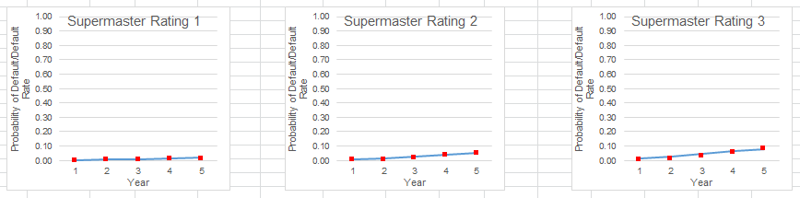

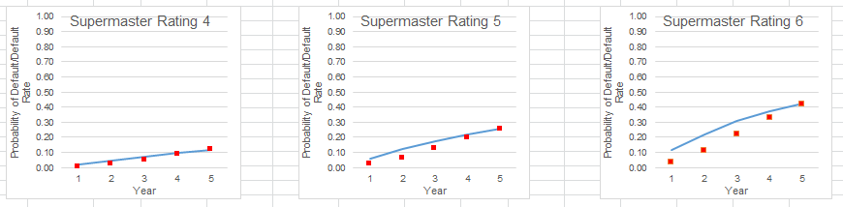

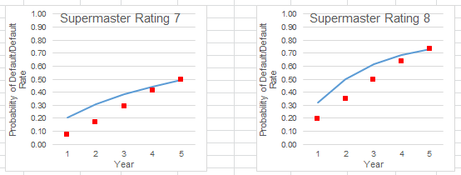

### Conversion from TTC to PIT PD

In this section, we will explain how to convert TTC PD obtained from the previous steps to PIT PD via the Vasicek equation. There are 2 components namely the and that would need to be identified. We suspect that the default rate of customer in each occupation segment i.e. salary earner and entrepreneur of the customer may have different relationship with macro variables. We segmented our samples into two group based on occupation. The definition of occupation is grouped as follow: entrepreneur and freelance are flagged as “Entrepreneur”, otherwise they are “Salary Earner”.

The data preparation is to identify which macro variable is suited for each sub-segmentation and it can be generated by seeking the relationship between actual default and macro-economic index via R programming. Specifically, the observation period is quarterly from Jan-2012 to April-2016 and the performance period is 1 year sliding window from Jan-2013 to April-2017. The good and bad definition is exactly the same as curve fitting in Non-homogenous section.

The historical macro variable index is based on the Bank’s internal organization research or “K-Research”. Since PIT PD is a forward-looking concept then the point of macro-economic index will be the next 12 months from observation point. The greater detail is shown as the following table:

|  |  |  |
| --- | --- | --- |
| No. | Name | Description |
| 1. | Date | Data monthly as of observation point from 200901 to 201603 |
| 2. | DR_Salary_Earner | 1 year actual default rate of Salary Earner from Date |
| 3. | DR_Self_Employed | 1 year actual default rate of Entrepreneur from Date |
| 4. | GDP_2002 | Historical Thai GDP data as of (Date + 12 months) |
| 5. | PRIVATE_CONSUM | Private Consumption index data as of (Date + 12 months) |
| 6. | INVESTMENT | Investment index data as of (Date + 12 months) |
| 7. | GOV_SPEND | Government spending index data as of (Date + 12 months) |
| 8. | EXPORT | Export index data as of (Date + 12 months) |
| 9. | IMPORT | Import index data as of (Date + 12 months) |
| 10. | UNEMPLOY_RATE | Unemployment rate index data as of (Date + 12 months) |
| 11. | HEADLINE_CPI | Headline CPI index data as of (Date + 12 months) |
| 12. | CORE_CPI | Core CPI index data as of (Date + 12 months) |
| 13. | DIESEL_PRICE | Diesel Price index data as of (Date + 12 months) |
| 14. | MLR | MLR index data as of (Date + 12 months) |
| 15. | HOUSE_PRICE | Houseprice index data as of (Date + 12 months) |
| 16. | HOUSEHOLD_DEBT | Household debt index data as of (Date + 12 months) |
| 17. | CCI | CCI index data as of (Date + 12 months) |

Table 17, Input data for macro-overlay model

We also randomly spit sample into testing and training i.e. 80 to 20 respectively. After that, we fit a linear model to the time series data to establish the relationship between macro variables and the default rates over time. The selections of independent variables are done via a backward selection process. However, the final set of macro-economic variables selected into the final model is based on economic intuition, predictive significance of the independent variable and a tolerable level of model accuracy (Adjusted Rsquare).

|  |  |  |  |  |  |  |  |  |  |  |  |
| --- | --- | --- | --- | --- | --- | --- | --- | --- | --- | --- | --- |
| Product | Occupation |  | | |  | |  | |  | | *Adjusted* |
| K-Leasing | Salary Earner | |  |  | |  | |  | | 40-50% | | |
| Entrepreneur | |  |  | |  | |  | | 40-50% | | |

Table 18, Final coefficient of macro-overlay model

After obtaining CAF, the next part is to calculate that is the best fit to the model. In other word, we put the actual default as PD PIT and PD TTC as forward-looking PD with calculated CAF from above then one can solve optimization problem to obtain . However, due to data availability with more prudential correlation, we use a benchmark from Moody’s for salary earner and empirical observation for entrepreneur result of 4 and 10 percent respectively. This is because we believe that entrepreneur is more sensitive to systematic risk than salary earner.

|  |  |  |
| --- | --- | --- |
| Product | Occupation | Correlation |
| K-Leasing | Salary Earner | 4% |
| Entrepreneur | 10% |

Table 19, Correlation factor

## Pre-Validation

### TTC Model

For the 1-year TTC PD in the master scale we have validate it using a binomial test

|  |  |  |  |  |  |
| --- | --- | --- | --- | --- | --- |
| Supermaster Rating | Asset_class | PD Master Scale  30/1/2018 | Critical PD  30/1/2018 | Actual DR  201612 | Binomial test |
| 1 | PL Normal | 0.16% | 0.20% | 0.17% | Accept |
| 2 | PL Normal | 0.56% | 0.62% | 0.54% | Accept |
| 3 | PL Normal (New) | 1.22% | 1.39% | 0.79% | Accept |
| 4 | PL Normal | 1.89% | 2.15% | 1.68% | Accept |
| 5 | PL Normal | 6.13% | 7.02% | 4.89% | Accept |
| 6 | PL Normal | 11.50% | 12.19% | 7.87% | Accept |
| 7 | PL Normal | 20.78% | 22.62% | 15.61% | Accept |
| Reschedule | Accept |
| 8 | SMA | 31.82% | 32.97% | 31.06% | Accept |
| Restructure(TDR) | Accept |

Table 20, Binomial test of Supermaster Scale

For the TTC PD term structure, the generator matrix and the curve adjustment parameters are calibrated to the PD term structure from Jan-2013 to Jan-2017. At the time of development, we have yet to identify an appropriate measure to validate the performance of the PD term structure. The optimization was performed to ensure that the modelled term structure closely matches that of the observations. Based on the sum square error of the actual vs. model prediction, the sum of squared error across all rating is attributed to approximately 0.137.

|  |  |  |
| --- | --- | --- |
| Curve Adjustment | SSE | MAPE |
| All | 0.13708 | <100% |

### PIT Model

The performance of the (linear model) is validated via adjusted . Both the salary earner and entrepreneur has an acceptable range of adjusted as follow

|  |  |  |  |  |  |  |
| --- | --- | --- | --- | --- | --- | --- |
| Product | Occupation | *β0* | *βUnemp.Rate* | *βHHDebt* |  | *Adjusted* |
| K-Leasing | Salary Earner |  |  |  |  | 40-50% |
| Entrepreneur |  |  |  |  | 40-50% |

Table 21, Adjusted for macro-overlay models

# Exposure at Default

Conditional Prepayment Rate

Conditional Prepayment Rate (CPR) measures prepayments as a percentage of the current outstanding loan balance. It is always expressed as a compound annual rate. A 10% CPR means that 10% of the pool’s current loan balance pool is likely to prepay over the next year. The CPR is commonly used to describe the prepayment for mortgage.

Term Loan

The mortgage industry of Thailand pays a major role in consumer lending business. The market is fiercely competitive. Both government and commercial banks attempt to attract borrowers by offering special interest rate programs. Several programs are created such as fixed 1-year rate, fixed 2-year rate, fixed 3-year rate, and etc. Borrowers can match the rate with their preference. Moreover, banks in Thailand allow borrowers to pay off the loan before the contractual maturity (pre-payment) without any penalty. So, pre-payment and pre-settlement significantly reduces Bank’s revenue. If banks can foresee which borrowers are certainly to make full prepayment or ones are to refinance, banks can prepare the rates matching borrowers’ behavior in terms of interest rate scheme and costs. Another advantage of predicting prepayment is that banks can more effectively allocate their provision matching borrowers’ behavioral life time.

Development of prepayment model can leads to more efficiently estimate customers’ lifetime and exposure curve. In other words, banks would like to know how long the borrowers stay in the portfolio and what the exposure curve looks like

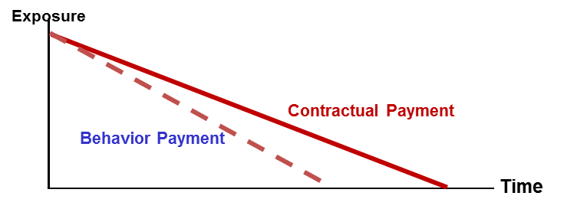.

Figure 6: Concept of Prepayment Model

As shown in Figure 7, with the effect of prepayment, the remaining of exposure would be reduced when compared to contractual exposure. The effect can be incorporated by %CPR in equation 1.

Equation 1

Where is the Exposure At Default at time

is outstanding amount at time

is conditional prepayment rate at time

is the monthly contractual cash flow which generates from non-ECL part

Conditional Prepayment Rate (CPR) is defined as percentage rate of current prior-outstanding that will prepaid at any given time i.e.

Equation 2

Where is the amount of actual payment made at time

is the amount scheduled to be paid at time

is the beginning of the period outstanding at time

(which essentially equals to end-of-period outstanding at time )

All K-Leasing loan products are term loan product so exposure at default (EAD) are related to term structure and prepayment rate. EAD for term loan products is express as a result of combining outstanding by term structure with prepayment rate but as nature of auto loan is charged at a fixed rate of interest which the interest will remain fixed during the tenure of the loan. Therefore, borrowers may not pay off the loan before the contractual maturity leading to no partial prepayment model (%CPR=0). Then, EAD for loan with fixed rate is equal to the contractual outstanding. As well as Consumer Loan, there is no partial prepayment model and as a result, EAD will be equal to the contractual outstanding.

## Scope

Exposure at Default (EAD) is defined as expected outstanding balance at the time of default. It is one of the major components in credit risk analytics, especially expected loss (EL). Along with Probability of Default (PD) and Loss Given Default (LGD), EAD is used to calculate EL and capital of the bank expressed as PD x EAD x LGD.

Based on nature of theKBank’s products, modeler discriminate them into 2 product types which are Term Loan and Revolving Loan. For Retail Credit products, term loan is consisting of Housing Loan, Staff Loan, Other Secured Loan and K-Leasing. EAD-TFRS9 model will be segmented based on Term Loan and Revolving Loan as shown in Figure 6 below. The first one is model for loan products and the other one is model for revolving products

**Retail Product**

**B. Revolving Loan**

1. **Term Loan**

**Credit Card**

**POD**

**Housing Loan**

Other Secured Loan

**Consumer Loan**

**K-Express Cash**

Other Unsecured Loan

**Staff Loan**

New Car

Used Car

K- Car

**K-Leasing**

Figure 7: Product Structure of KBank’s Retail Products

EAD development for K-Leasing (KL) is based on Term Loan and used for all KL sub-products such as New Car, KCar and Used Car.

# Loss Given Default

Loss given default, LGD, can be defined as the share of a defaulted exposure that will never be recovered by the lenders. The loss given default shall be assessed in an economic sense rather than a mere accounting perspective. That said the discount effect associated with the recovery cash flow and cost associated with collecting recoveries shall be considered.

LGD amount is the total EAD amount subtracted by the expected recovery amount and plus by the collection cost. Recoveries must include both late payments and the sale price of collateral when liquidated. The discount rate used should be the cost of equity, and recoveries should be discounted back to the date of the first missed payment leading to default. Then, to get the % LGD, the LGD amount is divided by the total EAD amount as shown in the equation below,

Where,

= LGD of customer *i* at time *t* after default

= recovered cash flows and predicted cash flows of customer *i* at time *j* minus direct and indirect costs associated with the collection process

= Expected cash flows of customer *i* at time *j*

= present value function using appropriate discount rate

= outstanding of customer *i* at the time of default

Recovery cash flow is the amount of loan or obligation that will possibly be repaid to creditors in the event of a default then deducted by the direct and indirect costs associated with the collection process.

For the formula of %LGD calculation as above will be applied to both customers whose cash flow process has already finished and those with unfinished cash flow process. With unfinished cash flow process customers, expected recovery cash flow was therefore required to calculate and aggregate with the actual cash flow (see more details in section 6.5).

Then post-default state of customer will be defined which can be separated into 4 states as following:

|  |  |
| --- | --- |
| Path | Explanation |
| Self Cured | The defaulted customer takes a certain amount of time to recover. However, No significant loss and no change in the structure or conditions of the facilities. |
| Early Cured | The defaulted customer takes a certain amount of time to recover and might not be able to fulfill his/her contractual obligations from time to time. However, No significant loss and no change in the structure or conditions of the facilities. |
| Liquidation | All facilities of the defaulted customers are liquidated. Collateral of K leasing business is a car. |
| Write Off | The defaulted customer who is not in above group and from the historical data has a significant loss comparing to the other path. |

## Scope

LGD for K-Leasing product is developed and used in all K-Leasing products including New Car, Used Car and KCar.

## Methodology Review

LGD can be measured using various methods such as the workout method used for both corporate and retail exposures, the market approach used for corporate exposures, the implied historical LGD approach used for retail exposures, and the implied market approach used for corporate exposures.

The most popular method for defining and observe actual LGD is the workout method. The idea here is to work out the collection process of a defaulted exposure and carefully inspect the incoming and outgoing cash flows. Both direct and indirect cash flows should be considered. Example indirect costs could be the operating costs of the workout department. These cash flows should then be discounted to the moment of default to calculate the loss.

There are many technique can be used to estimate LGD. For example one is to rely on segmentation of observed defaults from the past years, followed by developing regression-based model to estimate LGD within each segment. Regression-based model is to capture the key drivers of LGD including loan-to-value and implicit hair cut observed in the recovery process.

For K-Leasing product, a single average constant LGD is used for all K-Leasing products. There is no model for LGD.

### Model Assumption and Limitations

Assumption for using constant LGD for each product is that LGD depends on type of facilities such as unsecured loan, mortgage and leasing. For K-Leasing modeler proposed to use single constant LGD for all of K-Leasing sub products. This implementation assumes LGD does not depend on macroeconomic.

Limitation of using constant LGD is the ability to describe the dynamics with respect to changes in macroeconomic variables. As a result modeler will need higher margins of conservatism and therefore rather conservative LGD in practical use.

## Model Development Approach

#### Workout LGD Approach

The workout LGD methodology is based on the discounted of actual cash flows that can be recovered by the collection process from the date of default to the end of the recovery process. In addition, BIS (2004) states that banks who choose to calculate realized LGD using the workout method must include the direct and indirect costs associated with the collection of the exposure. Thus, we consider both costs in our LGD calculation. Direct costs are those associated with a particular asset, including fees for an appraisal of collateral, costs of selling assets, costs of running a business, and other professional fees. Indirect costs are necessary to carry out the recovery process but are not associated with individual facilities.

For KBank portfolio, collateral is generally held against a customer, not against an individual loan. Thus, for the calculation of historical LGD, it makes sense to view all of a given customer’s facilities as a single exposure, and calculate the severity based on this.

To calculate the direct workout LGD amount, the total EAD amount is subtracted by the expected recovery amount and plus by the collection cost. Recoveries must include both late payments and the sale price of collateral when liquidated. The discount rate used should be the cost of equity, and recoveries should be discounted back to the date of the first missed payment leading to default. Then, to get the % LGD, the LGD amount is divided by the total EAD amount as shown in the equation below,

Where,

= LGD of customer *i* at time *t* after default

= recovered cash flows and predicted cash flows of customer *i* at time *j*

= present value function using appropriate discount rate

= direct and indirect costs associated with the collection process

= outstanding of customer *i* at the time of default

#### Non-Closed Files Customer Treatment

When using the workout method, the problem arises of how to deal with partial recovery profiles of non-closed files. The non-closed files refer to defaulted customers in the database who do not yet complete the loan recovery process (i.e. many of the loans are still in the process of debt collection).

The simplest approach is to exclude these non-closed files from the LGD estimation process, with LGD based on closed files only. Whilst simple, results based on this approach may be affected by data selection bias if the non-closed files contain information relevant to LGD which is not captured by the recovery profiles of the closed files. Moreover, inclusion of the non-closed files may still be relevant if they contribute to reduce the error around the estimates (Rapisarda and Echeverry, 2010).

As a result, we include the non-closed files in the LGD estimation process and need to make an assumption on the recovery rate of the non-closed files. In doing so, we first divide the closed files into 3 main default pathways, and estimate each group recovery rates:

|  |  |
| --- | --- |
| Path | Explanation |
| Self Cured | The defaulted customer takes a certain amount of time to recover. However, No significant loss and no change in the structure or conditions of the facilities. |
| Early Cured | The defaulted customer takes a certain amount of time to recover and might not be able to fulfill his/her contractual obligations from time to time. However, No significant loss and no change in the structure or conditions of the facilities. |
| Liquidation | All facilities of the defaulted customers are liquidated. Collateral of K leasing business is a car. |
| Write Off | The defaulted customer who is not in above group and from the historical data has a significant loss comparing to the other path. |

Table , Paths and definition

We then classify the non-closed customers into each group of state and project each group’s recovery rates following those of the closed files. We project the remaining cash flows of non-closed customers based on the average recovery rate of closed group of customers by month. Here is the equation for this approach:

Expected Recovery (%) is derived from projected recovery rate curve of each state and segment group. We can generate this curve by dividing all cash flow by outstanding of all closed-customers in that particular group and repeat this step for the next month till the end.

For example, if the customer has % Actual Recovery equal to 20% at month 36 after NPL date. Then we get an expected recovery from the curve which appears to be 30% from month 36 to the end of recovery curve. As a result, % Recovery of this customer must be 50% (20%+30%). For LGD, the following formula will be used:

## Data Management

### Overview of Input Data Set

Data used in model development for LGD is K-leasing customers who hold any leasing product including New Car, Used car and KCar. The data needed to calculate LGD includes

1. Contract Data such as reference contract number, approved date, default date, exposure at default, final flag status and final pathway.
2. Cash flow collected from customers in each period after default

### Sample Design

Total number of account is 14,367 of default accounts during Jan 2009 – Jun 2016 are observed. Monthly recovery payment are observed after default to Jun 2017

## Model Development

### TTC Model

Actual recovery rate of pathways stated in Modeling Methodology of closed files customer are shown below

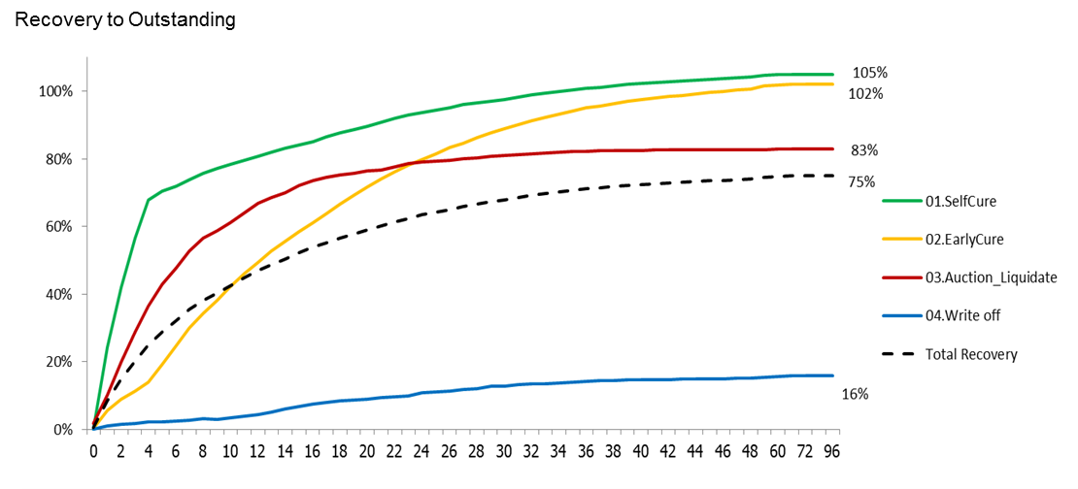Figure 8: Recovery Rate Curve of closed-customers

The observed LGD for each pathway are shown in table below. The final observed LGD for K-Leasing product is LGD of each path weighted average by exposure at default which is 26%. Due to there is no model for LGD to capture macroeconomic variation effect, modeler need more conservative value to be used as final LGD for both through-the-cycle and point-in-time LGD. The final constant used for both through-the-cycle and point-in-time LGD is set to equal to downturn LGD at 33.42%

Table 23: Expected Loss Given Default Each Path

|  |  |
| --- | --- |
| Path | LGD |
| SelfCure | 0% |
| EarlyCure | 0% |
| Auction_Liquidate | 17% |
| Write off | 84% |
| NPL | 66% |
| Total LGD | **26%** |

Table 24: Final LGD

|  |  |  |
| --- | --- | --- |
| Product | Observed LGD | LGD  (Downturn & TT&PIT) |
| K Leasing | 26% | 33.42% |

### PIT Model

For LGD of K-leasing, all point-in-time LGD will equal to through-the-cycle LGD because there is no model to adjust.

## Pre-Validation

LGD developed for K-Leasing product is not statistical model but a constant that averaged from all long-term currently available historical data so model validation at development stage is not necessary.

# Criteria for Significant Increase in Credit Risk (SICR)

With the new IFRS9 loan loss provision, loans are classified in three stages: stage 1 – initial recognition (yet to be impaired), stage 2 – significant increase in credit risk, and stage 3 – objective indicators of impairment. For loans in stage 1, banks need to estimate 1-year expected credit losses. On the other hand for loans in stage 2 and 3, banks need to provide provision and thus estimate expected credit losses for the whole lifetime of the loans. Both the 1-year and lifetime expected credit losses estimation shall reflect the banks’ forward looking macro-economic view.

The criteria for significant increase in credit risk (stage transfer criteria) will be used for the classification of loans between stage 1 and stage 2. KBank employed both the qualitative and the quantitative criteria for stage classification. An example of qualitative stage transfer criteria stage is the 30+ days past due (DPD), fraud, black list from the revenue department and so on. Thus, all instruments with DPD>30 days are automatically classified as stage 2. This model development document solely focuses on the formulation of the quantitative stage transfer criteria.

This section of the document outlines the methodology review and the development including any expert opinions and judgements of our champion significant increase in credit risk criteria. KBank explore four methodologies to develop the quantitative criteria the significant increase in credit risk namely the rating downgrade criteria, the remaining lifetime PD criteria, the forward run test and the high credit risk region. In each of the methodology, KBank leverages existing behavioral scorecard, supermaster rating transition matrix and PD term structure to induce statistical inference and the formulation of the criteria itself.

## Scope

Both the qualitative and quantitative stage transfer criteria are applied to all non-NPL instruments. All non-performing loan instruments are automatically assigned to stage 3.

* 1. **Modelling Methodology Review**

### Rating Downgrade

The rating downgrade is a quantitative stage transfer criteria that contemplate on the rating downgrade compared to the rating assigned at the loan origination. If the number of rating downgraded of an instrument is greater than a given threshold then the instrument is deemed to be a significant increase in credit risk and assigned to stage 2. The number of rating downgrade can be identified illustratively in the figure below.

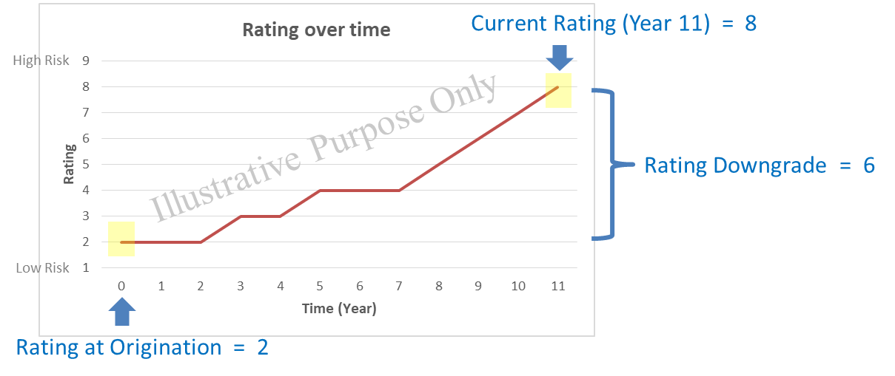

Figure 9, Rating observation: origination vs. reporting

For retail portfolio, we use an empirical rating migration from bootstrapped samples to construct the threshold for notch change (between 75-85 percentiles depending on the portfolio).

### Remaining Lifetime Probability of Default

The remaining Lifetime PD stage transfer criteria recognize if the remaining lifetime probability of default at the reporting date has deviated statistically from the lifetime probability of default estimated at origination. This measure is highly sensitive to our choice of PD term structure model. By default this compares the lifetime PD generated from the champion model of each portfolio.

In short, the significant increase in credit risk under this criteria is SICR is reflected by statistical deviation in **[1] the remaining Lifetime PD estimated at origination** compared to **[2] Lifetime PD at reporting date**. The statistical deviation in this criteria is founded on a confidence band based on the average deviations in the marginal probabilities over time (for each supermaster rating). The standard deviation for our confidence band is illustratively measured as per the following figure

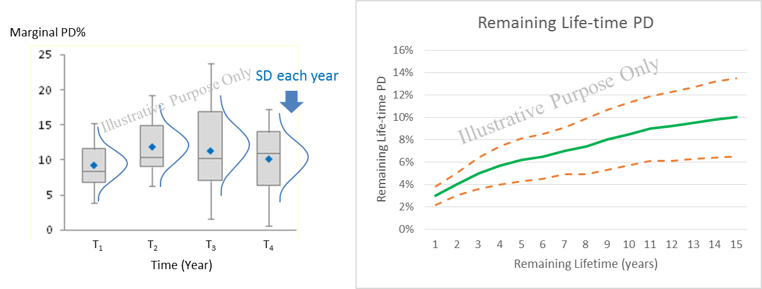

Figure 10, Standard deviation and confidence band for Lifetime PD

After the average standard deviation of marginal probabilities has been defined . We generate the confidence band for each of the remaining lifetime as follow

Where is the average standard deviation of the mariginal PD for rating

is the cumulative PD at estimated origination (origination rating ) upto maturity date

is z-value of a confindence level (by default 80%, two-tailed)

### Forward Run Test

The forward run test criteria check if the Forward PD at reporting date has significantly increased from the Forward PD at the similar point of time estimated at origination. If we were to plot forward PDs of two time series [1] Forward PD from origination and [2] Forward PD at reporting date, we can compare the two time series using run test to see if they are statistically different as illustrated in the figure below.

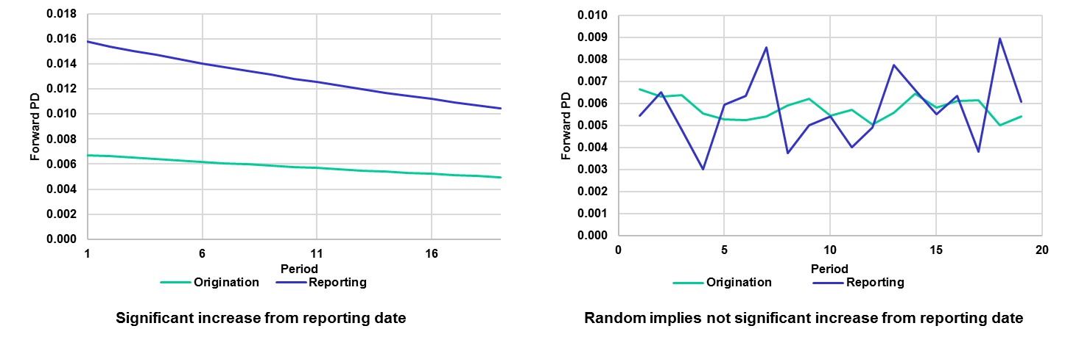

Figure 11, forward PD run test

The hypothesis of the forward PD run test is defined as follow

*H0: Forward PDs at origination date and at reporting date are not different*

Test statistic

Where is the observed number of runs

are the number of origination and reporting date values

### High Credit Risk Region

The high credit risk region is our final significant increase in credit risk criteria which may be use in conjunction with other criteria. The high credit risk region is defined as a supermaster rating threshold. If a credit rating of an instrument are greater than the prespecified value then it is automatically assigned to stage-2.

The conception of the high credit risk region would start with an observation of the average rating of a portfolio. We’ll then use an associated rating downgrade threshold as the high credit risk region for the portfolio. The setting is further validated by testing the equivalent of survival curves i.e. between the low credit risk and high credit risk region.

The hypothesis of the equivalency of survival curve is defined as follow

*H0: The customers with credit rating higher than the HCRR threshold have equivalent survival curve to those customers with ratings better than the threshold.*

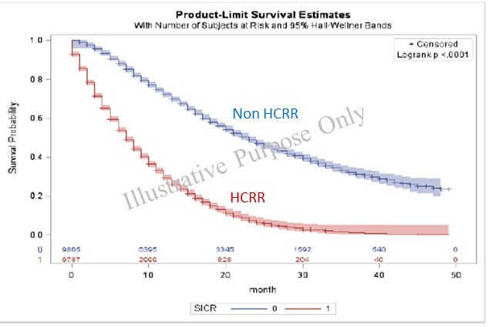

Figure 12, Equivalency of survival curves between HCRR and non-HCRR

## Model Development Approach

For significant increase in credit risk criteria, KBank believe that the rating downgrade and the high credit risk region are the appropriate methodologies to be used as chamption criteria. The main reason for this is the fact that the methodology is lower in complexity in terms of both the data requirement and system implementation. The inputs of the model and the development exercise align with the bank’s current data structure. The output of model also aligns with current business model and TFRS9 risk requirements in term of classification of instruments whose credit risk have increase significantly. Other methodologies are explored and implemented as challenger SICR criteria.

This section briefly outline the steps that have been taken in the development of the champion SICR criteria i.e. rating downgrade and high credit risk region. The development SICR model is done successively to the development of PD model and will be using an identical sampling data. Figure below outline the steps taken in the development of rating downgrade and high credit risk region.

Figure 13, Steps of development: stage transfer criteria

The development process starts with consolidation of portfolio data across time into a single data set (these are the same data set which are used in the PD model development). Then development samples are created by bootstrap sampling from the large data set. We then observe the 75 to 85 percentile of migration for each of the initial rating in each of the sample. The observed mode of the 75-85 migration percentile (based on expert opinion) across multiple bootstrapped samples are then selected as a downgrade criteria.

For the high credit risk region, we observe the average supermaster rating of an entire portfolio in the data set then we use the downgrade criteria for that rating as a high credit risk region.

## Data Management

For data management, please refer to the Data Management section for the modelling of the probability of default term structure.

## Model Development

### Rating Downgrade

The development of rating downgrade criteria starts with the bootstrapped sampling to observe the rating (supermaster) migrations. For each initial rating, we then observe the distribution of the 12-month rating change as per the following figure.

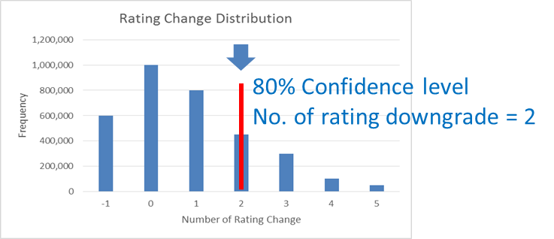

Figure 14

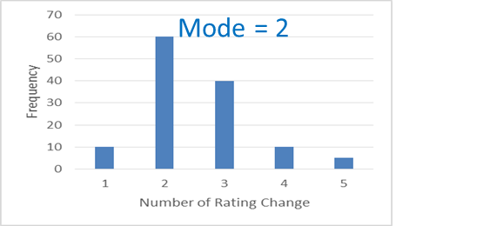

Figure 15, Rating change distribution and mode of bootstrapped sample

The steps are repeated across multiple (100) bootstrapped samples to observe (100) of 80th percentile of the 12-month rating change. The mode of these 80th percentile numbers is then chosen as a downgrade criteria. The result of this exercise are the number of downgrade rating change for each of the initial (origination) rating. The result is then overridden with few expert judgement to maintian the monotonicity of the downgrade for each of the initial rating. The results are as follow

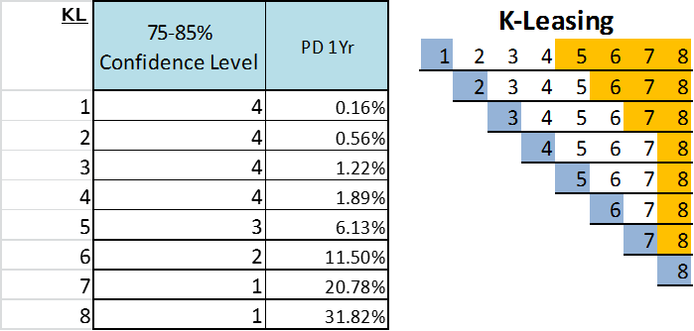

Figure 16, Final rating downgrade criteria

### High Credit Risk Region

As mentioned previously, the high credit risk region is essentially the rating downgrade (change) of the average portfolio rating which in this case is rating 4. The high credit risk region is thus rating 8 or greater. The distribution of customer that falls under and in the high credit risk region is shown in the table below.

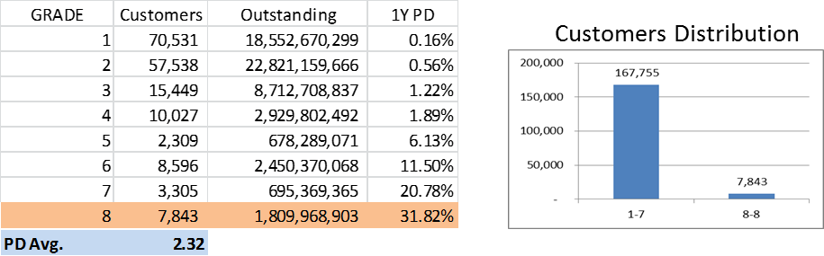

Figure 17, Final high credit risk region criteria

We validate this setting by considering the survival curves of each segment i.e. low credit risk region vs. high credit risk region. The validation results show that the survival curves are vastly different and the high credit risk region setting is appropriate. Results of validation are shown below.

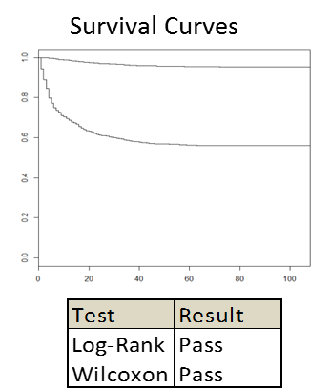

Figure 18, Validation of HCRR, equivalency of survival curves

1. http://www.IFRS.org/current-projects/iasb-projects/financial-instruments-a-replacement-of-ias-39-financial-instruments-recognitio/documents/IFRS-9-project-summary-july-2014.pdf